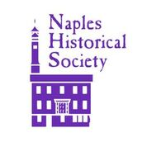
NAPLES HISTORICAL SOCIETY
PO BOX 489
NAPLES, NY 14512
NEWSLETTER – NOVEMBER, 2018

REMINDER: ANNUAL MEETING NOVEMBER 15
7 PM MORGAN HOSE BUILDING

The year seems to have passed quickly. As suggested in the February newsletter, it has proven to be a busy year so far and shows no sign of slowing down.

Our Spring Dinner was held at Roots Café on June 13. Fifty members and friends enjoyed a chicken linguini in white wine sauce dinner. Dessert followed at the Cleveland House where Mike Terry presented the program on the Cleveland House and the early part of the town. During the presentation, Mike announced to the audience that the Historical Society was in the process of purchasing the Cleveland House, built in 1794 by Captain Ephraim Cleveland.

The purchase of the Ephraim Cleveland house has now been completed. Members of the NHS have worked on cleaning up the yard and are going to prepare the house for the winter. Plans for the museum aspect of the building will be worked on during the winter.

Capt. Cleveland, a revolutionary war soldier , came to Naples with his wife Mary and his children Ephraim and Olive in the spring of 1791 with other early settlers. The Capt. was a farmer and a surveyor. He helped found the village and was active in early government.

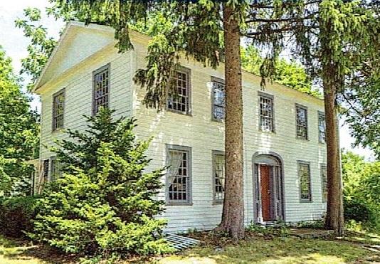

The original house was 20 ft. by 48 ft. The back section was built in the 1850’s. There is a large center chimney with a fireplace in each of the four main rooms of the original house.

The walls in the west second floor bedroom are stenciled. The stenciling is was done by Stephen Clark. Stephen was said to be the first college graduate from Naples. The paint he used was made of eggs, buttermilk, berries and other natural dyes. The legacy of the Cleveland House is that those walls have never been altered.

Elisabeth Cowley took an historical walk with 2nd graders on a wet spring morning. The weather did not dampen the students’ spirits as they learned about the area that became the first settled part of our town, the Town Square and vicinity. Historical programs will be available in the future for public and home school groups.

Naples Town Historian and former NHS President, John Murphy, led a History Walk in the area of the original town on April 22. This area includes many early houses, the cemetery, the Town Square and more. Over 50 people participated and the weather cooperated with a lovely spring day.

John Murphy also led a Walk/Talk on July 29 on the Memorial Town Hall. What makes the building more unique is the fact that it was built as a memorial to the men from Naples who served in the Civil War. Buildings as Civil war memorials are rare.

The Scandinavian Raffle was completed with the drawing of prize winners at the July 30 Board meeting. The raffle raised $2350 which will be put toward expenses for the Cleveland House

Boo Herman- Bob’s & Ruth’s
Barb Hawks - Brew & Brats at Arbor Hill
Carol Hicks - China City
Bob Metcalf - Grainery
Sonja Torpey - Luigi’s
Patrice Lysell - Middletown Tavern
Ann Marie Rotter - Monica’s Pies
John Cowley - Monica’s Pies
Diana Lyon - Neapolitan Brick Oven
Cindy Scoda - Sawmill Restaurant
Val Knoblauch - Resevoir Golf Club
Diana Lyon - The Naples Hotel

Beth Flory Remembered – Beth Bishop Flory passed peacefully on May 6, 2018 in Florida. In 1990, Beth and her husband Rev.Sheldon Flory retired to Beth’s beloved summer home on Canandaigua Lake. Beth is survived by her three children: Daniel Odell (Judith) of Cohoes, NY; Elisabeth Grant (John) of South Hampton, MA; and Katharine Odell (Thomas Henecker) of Cape Coral, Fl and four grandchildren.

Beth became active in Naples area organizations. For many years she served as President of the Naples Historical Society during the many years of the restoration of the Morgan Hose Building. She also served as a board member of the South Bristol Historical Society, the Shaker Heritage Society and the Nundawaga Society for History and Folklore. For many years she wrote the “Glancing Backward” column for the Naples Record and had many local area history articles published in the Crooked Lake Review. In 2004 she was chosen a Paul Harris Fellow by the Naples Rotary Club for her many contributions to her community.

A memorial service was held at Baird Funeral Home on August 4, 2018. The Naples Historical Society hosted a gathering for family and friends at the Morgan Hose Building.

Several members of NHS met with Beth in the summer of 2017 while she was staying at the Lake. We were able to show her how things were progressing with the Mill and Morgan Hose Building. We showed her our work on listing contents of over 130 boxes of documents, photos, new clippings, papers, etc. It was a fun get- together.

CASH DONATIONS were received from members as they paid their dues:

Alison Hurst, Pam Lazio, Marilyn Cornish, Brenda Keith, Martha Reddout, Karen Sutton, Tom & Marcia Smith, The Iuppa Family, Jackie Faul, Steve Hamlin. An additional thank you to Alison Hurst for archival and office supplies she purchased on behalf of the Historical Society collection committee.

Donations in memory of Beth Flory from family: Dan Odell, Betsy Grant, Katy Odell and friends: The Knight Family, Mendon; the Carboni Family, Schenectady; Jean Griffith, Kennett Square, PA; Sherin Family, Delmar; Susan Hartwell, Canandaigua.

In preparing for the Grape Festival and the World’s Greatest Grape Pie Contest, the Naples Historical Society sponsored a pie baking class with Meghanne Frievald, a previous winner of the contest, as instructor for the grape pie baking class. It took place on Saturday, September 22. The class was held at the Trinity Federated Church and was filled to capacity with participants from a variety of age groups.

The World’s Greatest Grape Pie Contest was held on September 29 during the Grape Festival. There were 22 entrants to the contest. The winner was Alissa Brennan, 2nd was Karen Gotham, 3rd was a tie between Meghanne and Patrick Frievald and 4th was Pidgeon Iuppa.

Charlie Kingsly spent many hours this summer working on the Mill basement rebuilding the door and pointing the inside stone wall.. Paul Lambiase installed shelves in the kitchen area. He is currently finishing the repainting of the 1st floor room. Thank you to all the volunteers who have given their time.

The organ, in the meeting room, was donated many, many years ago by the Fleischman family. It is undergoing a restoration by Parsons Pipe Organ Builders at no cost to the Society. Thank you.

Do you want to make a gingerbread house? Check out the Naples Gingerbread Registration Survey at Naples Historical Society FB page or send e-mail to naplesgingerbreadvillage@gmail.com by November 16.

Reminder to those registered for the Cornhusk doll-making workshop, the workshop is tomorrow, November 10 at 10 AM.

Dues for 2019 are now due and payable. The Board of Directors raised the dues to $15 for 2019. If you have a question about whether you owe dues for this year, send an email to mabanaszew@aol.com. If you are coming to the annual meeting you can check then. We have attached a membership form to this mailing that can be filled out and brought to the meeting or send via regular mail if you are not able to attend on Thursday, November 15, at 7 PM.

